Eulogy - Professor Tetsuo Kanno (1940-2021)
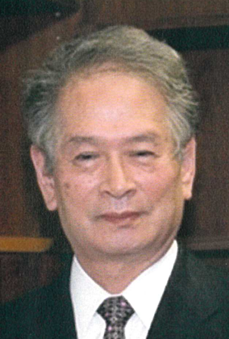
It is with deep regret that we announce the passing of Prof Tetsuo Kanno on 6 August 2021.

Prof Kanno was President of the Asian Australasian Society of Neurological Surgery from 2003-2007 and successfully organised the 12th AACNS in Nagoya, Japan in 2007.

He was a great educator and was the driving force behind the Young Neurosurgeons Education courses in the early 1990s, which subsequently morphed into the Asian Congress of Neurological Surgery. These courses benefited thousands of neurosurgeons in the region, and exposed many young neurosurgeons in Asia starting out in their careers, to the master neurosurgeons of the day, and aspired them to become the neurosurgical masters of the future. Many of the prominent neurosurgeons in the region today, who are now neurosurgical leaders in their own countries, still consider these courses a cornerstone of their practice, and fondly refer to Professor Kanno as their mentor and teacher.
Professor Kanno received many honours in his native Japan and from around the world, but his real legacy lies in his successful efforts in bringing neurosurgical education to Asia and other parts of the world and in the thousands of neurosurgeons today who call him their teacher and mentor.

His passing is a tremendous loss to all of us in the neurosurgical community in Asia. He will be dearly missed.

